EOH Fileserver Remote Access

The following how-to guide shows you how to connect to the Department of Environmental and Occupational Health’s network remotely. With this connection you will be able to access your folders (R, Z and U drives) as well as other departmental networked devices from outside the university.

**Pulse Secure Installation**

To connect to our network you must first install Pulse Secure (Pulse VPN Desktop Client), this free program works on Windows and Macintosh computers and can be downloaded from the University Software Download Service located at (<http://my.pitt.edu>). You must install the proper program for your computer, there are three choices for download: Mac, Windows 32-Bit and Windows 64-Bit

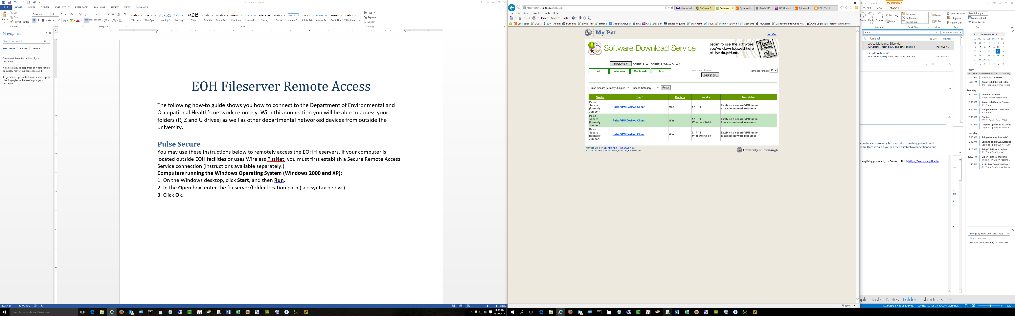

**Connecting**

Once you have Pulse Secure installed you can add a VPN connection to our network. Here are the steps to establish a connection:

1. Open Pulse Secure
2. Add Connection (this only needs done once, after that you can click on the name to reconnect). After entering the information click “Add”, in the Name field you can put anything you want, for Server URL it is <https://sremote.pitt.edu>

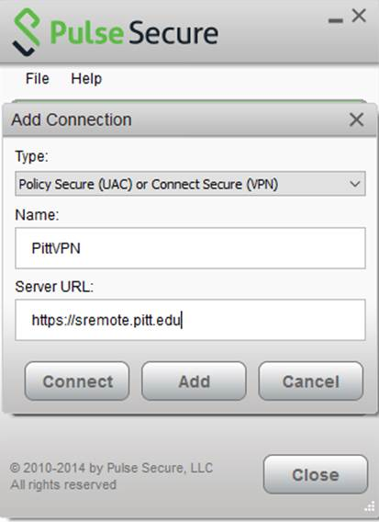

1. After hitting “Add” you should then be at the connection screen again, select the connection you just added previously and click on “Connect”

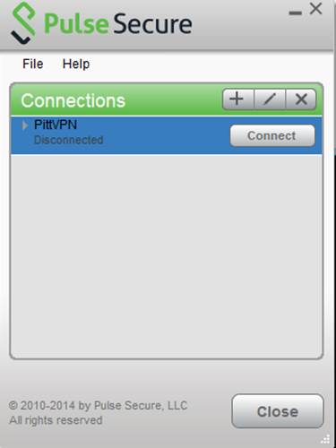

1. The program will now ask you to connect to a realm, select “Network Connect” and “Save Settings”, then click “Connect”

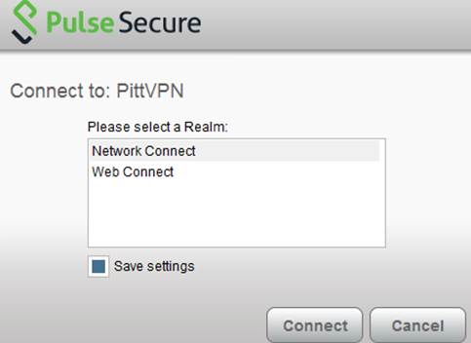

1. Enter your Pitt username and your Pitt email password, select “Save Settings” and then click “Connect”

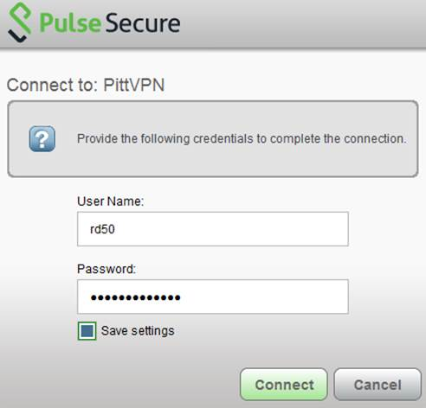

1. Select “**Firewall-EOH-Users-NetworkConnect**” from the list and select “Save Settings”, then click “Connect”

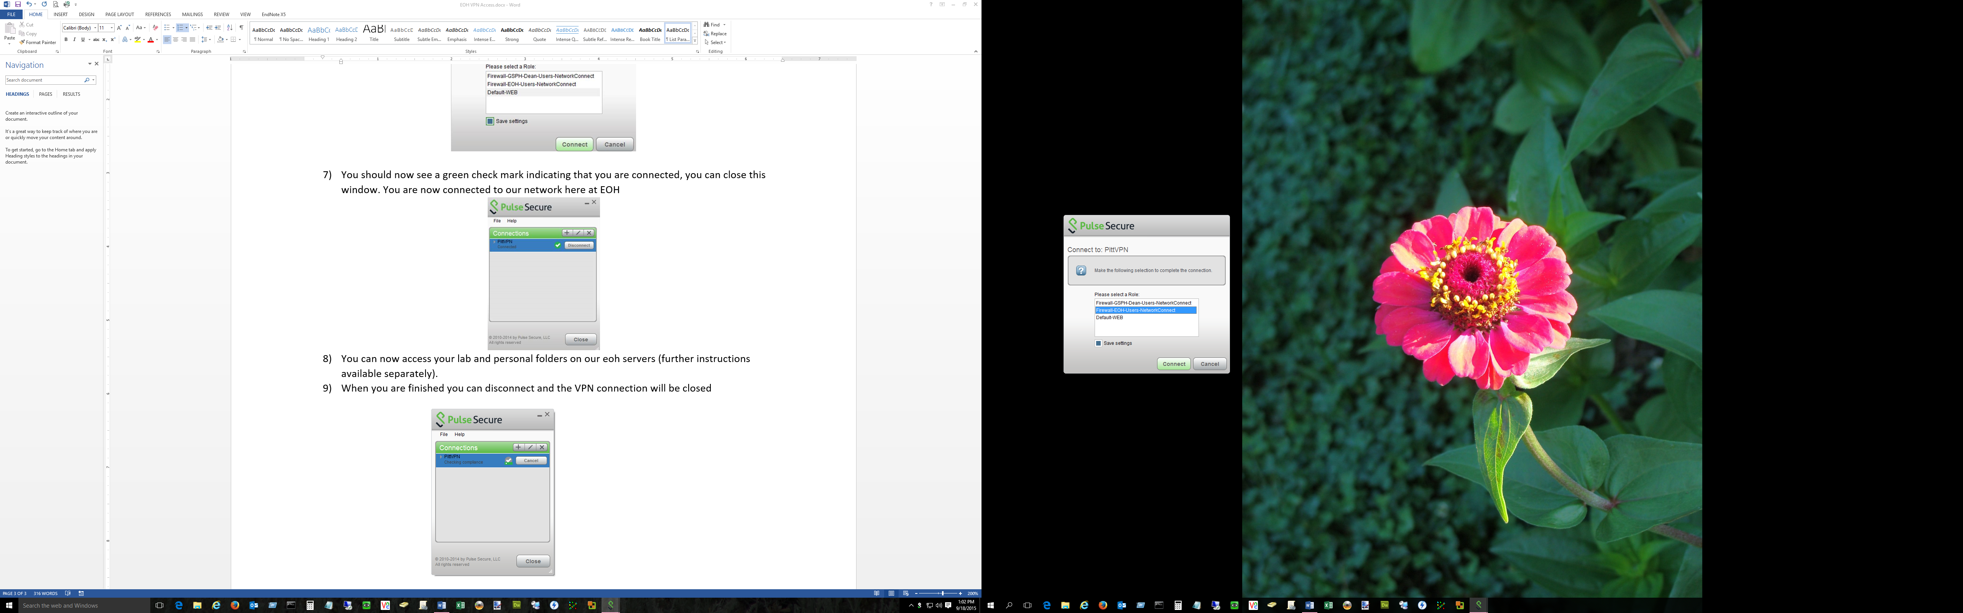

1. You should now see a green check mark indicating that you are connected, you can close this window. You are now connected to our network here at EOH

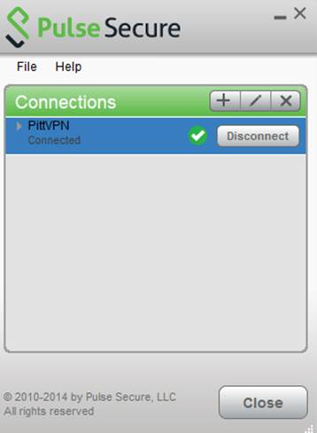

1. You can now access your lab and personal folders on our eoh servers (further instructions available separately).
2. When you are finished you can disconnect and the VPN connection will be closed
3. To reconnect, open Pulse Secure again and click Connect on the connection that was previously created and saved