The procedure to log into the Pitt Public Health IT Support system has changed. You’ll now need to:

- Browse to https://pittpublichealth.freshdesk.com/
- Click “Login” on the top right of the main support page (like you always have).
- Click “Are you a Customer?” under the email and password boxes.
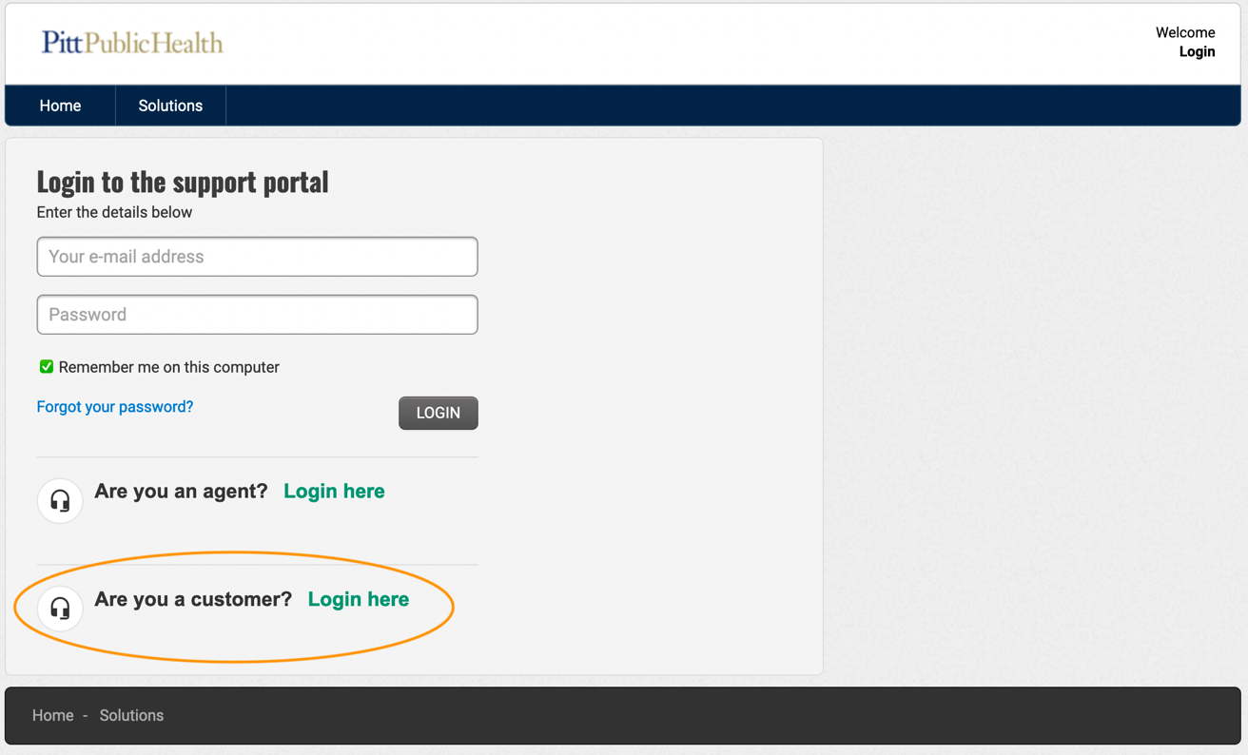
- Click on Sign in with SSO
- Login to Pitt Passport with your Pitt credentials.

