These settings need to be updated whenever I change my Pitt password. Otherwise, communication will be broken to the virtual CATi server (and the Sensus server which talks to Qualtrics server)
Solution: authentication identity under CATi2/application pool/defaultAppPool/advanced settings needed to be set to arndtd@pitt.edu
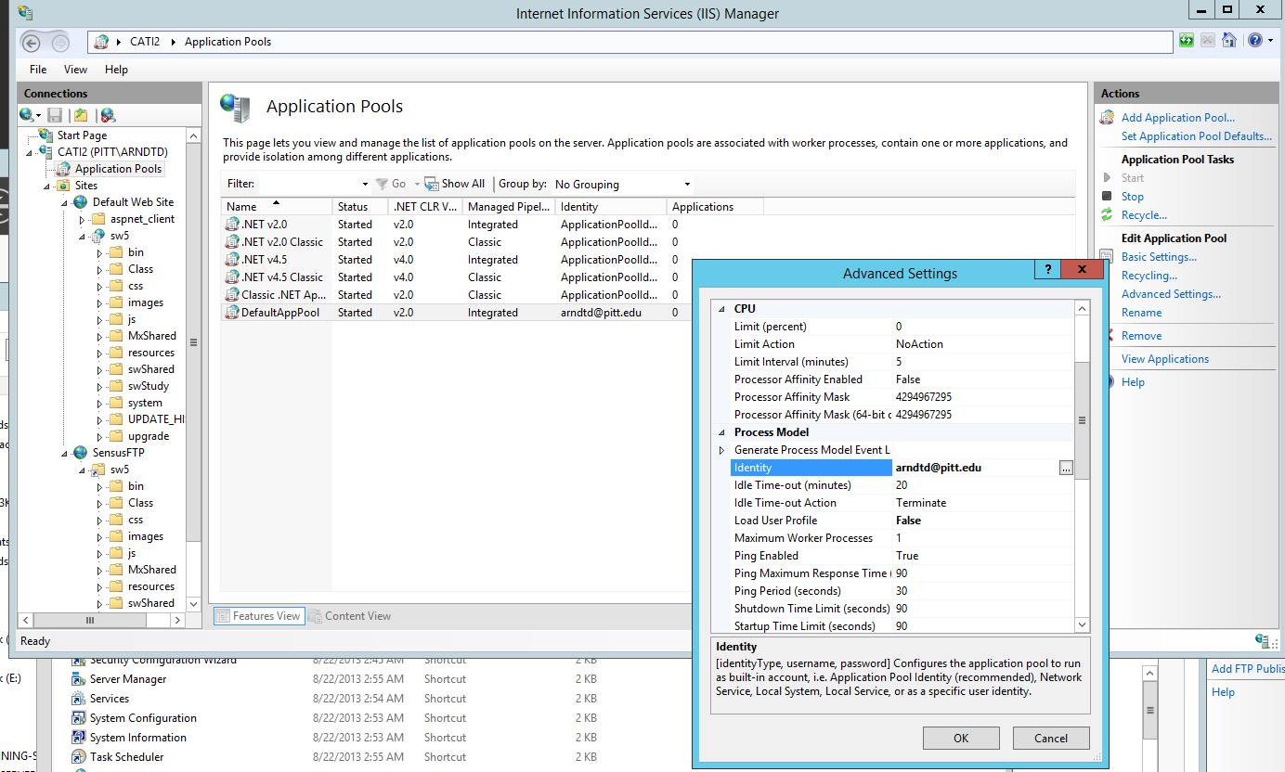
Also check: Default Web Site/basic settings/Connect As/arndtd@pitt.edu
sw5/basic settings/Connect As/arndtd@pitt.edu
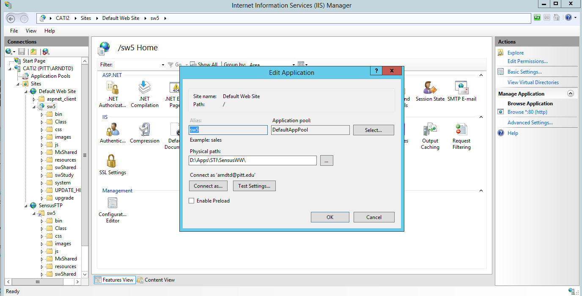

Also check: Sensus FTP
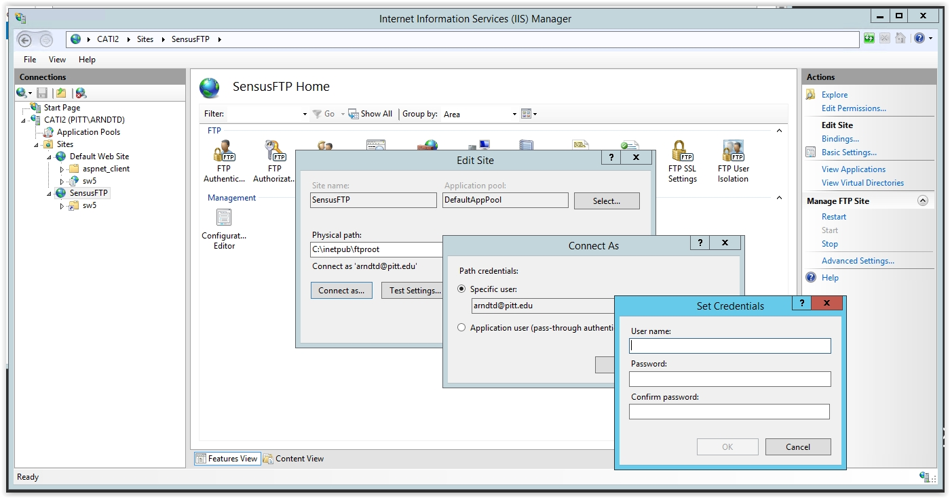

Also check: virtual directory
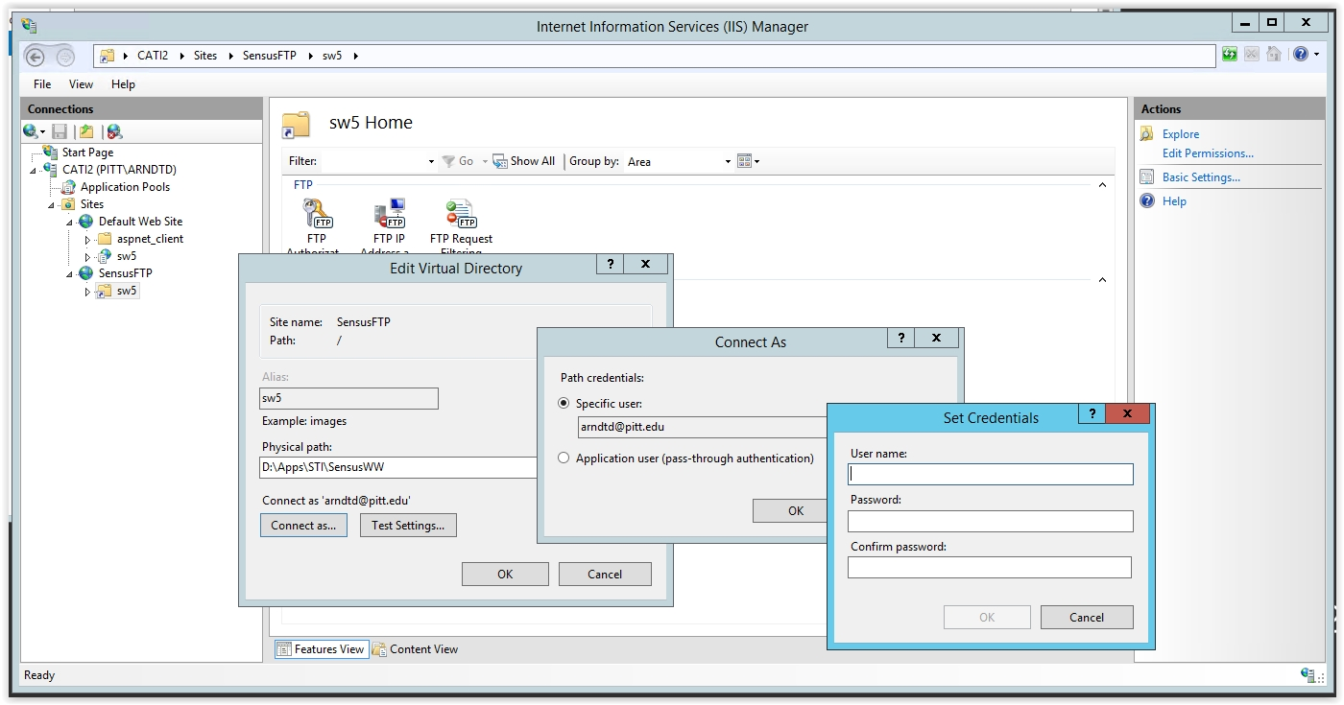

Also check sw5-Advanced settings:
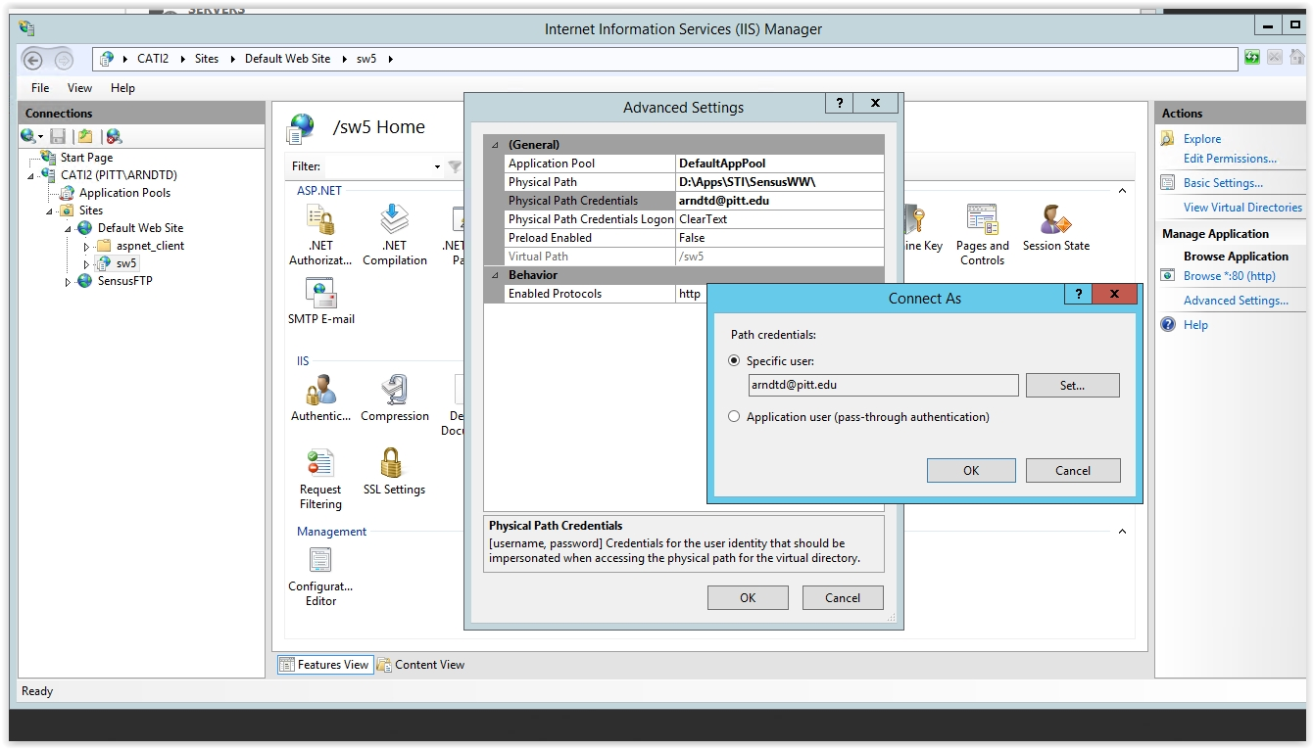
When we click on http://cati2.gsph.pitt.edu/sw5/ssvec.aspx
We should land here:
