Using the Sharp Monitor (Parran South Conf. Rooms)

When using the remote, point it at the word SHARP on the bottom of the monitor frame.

If the remote is missing or doesn’t work, there are manual buttons behind the left edge of the monitor as you face it. (Top button-Power; 2nd button-Menu; 3rd button-Input; 4th button-cannot operate; 5th button-cannot operate; 6th button-sound up; 7th button-sound down.)

1. Connect your laptop to the HDMI cable or the VGA cable. Connect the other end to the jack in the wall underneath the monitor cabinet. Use HDMI if you can; the VGA display is less sharp.
The HDMI cable carries sound as well as video, but older laptops may not have a jack for it.
The VGA cable carries video only, so if your presentation needs sound and you’re using the VGA cable, also plug the audio cable that’s connected to it into your laptop’s headset jack and the jack in the wall beneath the monitor cabinet.

HDMI jack and cable: VGA jack and cable:
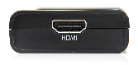
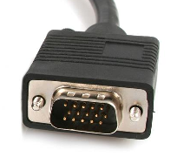
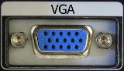
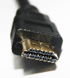

2. Use the remote and press the POWER button to turn on the monitor. You’ll see a white power light appear on the bottom frame of the screen, beside the word SHARP.

3. If your laptop is not automatically projecting, press the INPUT button on the remote (to the right of the Ch button). You’ll see a list of choices. Press the Input button repeatedly to cycle through the choices.
Select HDMI1 if you’re using the HDMI cable, or PC IN if you’re using the VGA cable.

4. If your laptop still doesn’t project, it may be your laptop. Check that it’s set to duplicate its screen (usually by pressing an Fn key together with an F key in the top row that has icons looking like monitors or screens). If that doesn't help, try changing your laptop’s display resolution (right-click on the Desktop, select Screen Resolution, try another resolution).

5. If your laptop projection doesn’t fill or overfills the monitor screen, press the VIEW MODE button on the remote (above the Ch button). Arrow up or down and try another choice. The "dot by dot" mode seems to work best for HDMI. If that doesn't help, try changing your laptop’s display resolution (right-click on the Desktop, select Screen Resolution, try another resolution). Some older laptops may not be able to fill the screen completely.

6. When you're done, turn off the monitor. Disconnect the cables and leave them inside the cabinet with the remote. Close the cabinet doors (when you close them, press on the middle of the edges where they come together so they click on top and bottom and stay shut).

If you need help, contact the department that handles the room; for rooms 4128 and 4140 call the Dean's Office IT support line at 412-648-9963, or email gsphit@pitt.edu.

